EXPT NO: 1 | BUILDING AND TRAINING A SIMPLE ARTIFICIAL NEURAL NETWORK (ANN) FOR REGRESSION AND CLASSIFICATION
DATE:

PRE-LAB QUESTIONS (PROVIDE BRIEF ANSWERS TO THE FOLLOWING QUESTIONS)

- What is an Artificial Neural Network (ANN)?

An Artificial Neural Network (ANN) is a machine learning model inspired by the structure of the human brain. It consists of interconnected neurons arranged in layers to process data. ANNs learn patterns by adjusting weights during training using optimization algorithms. They are capable of solving both regression and classification problems. ANNs are widely used in image recognition, speech processing, healthcare, and predictive analytics.

- What are the functions of the input, hidden, and output layers in an ANN?

The input layer receives the features from the dataset and passes them to the network. The hidden layers perform computations and extract meaningful patterns using weights, biases, and activation functions. These layers help the model learn complex relationships in the data. The output layer produces the final prediction or classification result. Its structure depends on the type of problem being solved.

- Why is feature scaling important before training an ANN?

Feature scaling ensures that all input features are on a similar numerical scale. It prevents features with larger values from dominating the learning process. Scaling improves the convergence speed of optimization algorithms like Adam and Gradient Descent. It also helps the neural network achieve better accuracy and stability during training. Common scaling methods include Standardization and Min-Max Normalization.

- Differentiate between regression and classification problems with examples.

Regression predicts continuous numerical values, whereas classification predicts discrete class labels. For example, predicting house prices is a regression problem because the output is a numeric value. Detecting whether a tumor is malignant or benign is a classification problem because the output belongs to predefined categories. Regression commonly uses MSE or MAE as evaluation metrics, while classification uses Accuracy, Precision, Recall, and F1-score.

- What is the role of the activation function in a neural network?

The activation function introduces non-linearity into the neural network. Without activation functions, the network would behave like a simple linear model and fail to learn complex patterns. Different activation functions such as ReLU, Sigmoid, and Tanh are used depending on the application. They determine whether a neuron should be activated based on its input. This improves the learning capability and overall performance of the ANN.

AIM
To understand the implementation of Artificial Neural Networks (ANN) using TensorFlow and evaluate their performance on regression and classification problems.

SOFTWARE REQUIREMENTS
- Python 3.x
- Google Colab / Jupyter Notebook
- TensorFlow 2.x
- NumPy
- Pandas
- Matplotlib
- Scikit-learn

LEARNING OBJECTIVES
After completing this experiment, students will be able to:
- Understand the architecture of an Artificial Neural Network.
- Build an ANN for regression problems.
- Build an ANN for classification problems.
- Train and evaluate neural network models.
- Compare different evaluation metrics used for regression and classification.

Task A – ANN FOR REGRESSION
DATASET: California Housing Dataset
SOURCE: Scikit-learn
DESCRIPTION
- Samples: 20,640
- Features: 8
- Target: Median House Value

FEATURES
Feature | Description
MedInc | Median Income
HouseAge | House Age
AveRooms | Average Rooms
AveBedrms | Average Bedrooms
Population | Population
AveOccup | Average Occupancy
Latitude | Latitude
Longitude | Longitude

ALGORITHM
- Import libraries.
- Load California Housing dataset.
- Split into training and testing sets.
- Standardize the features.
- Build ANN model.
- Compile the model.
- Train the model.
- Predict house prices.
- Evaluate using:
  - MSE
  - MAE
  - RMSE

(CODE: CONATAINS STUDENT ROLL NOS
SCREENSHOT OF CODE
SCREENSHOT OF OUTPUT)

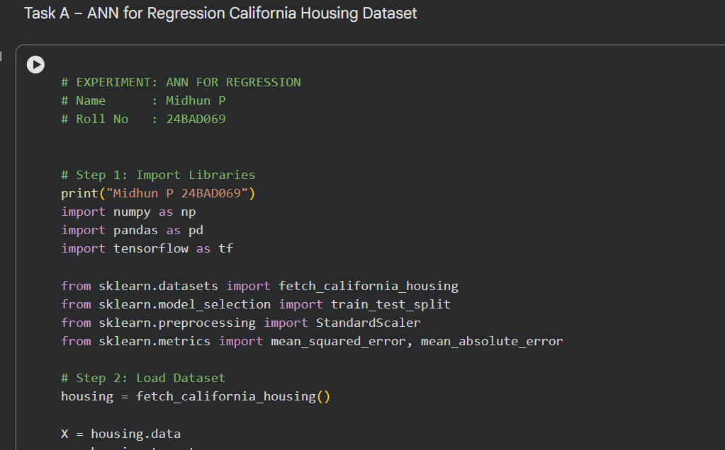

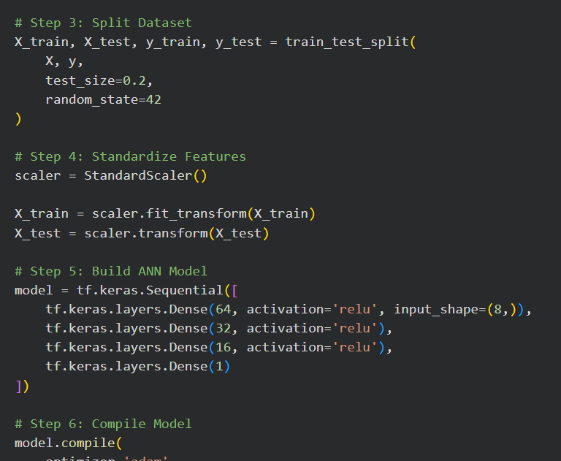

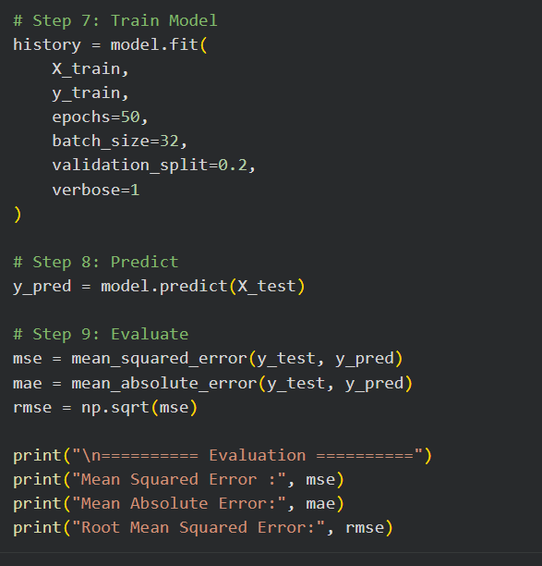

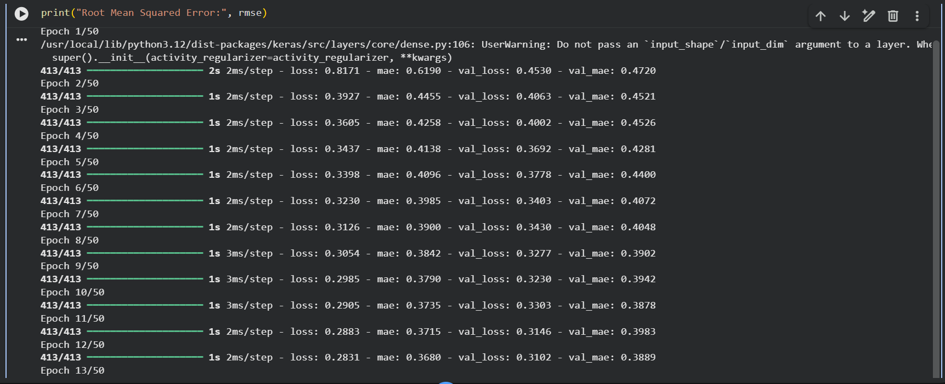
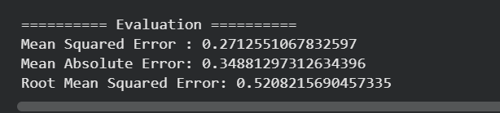
Task B – ANN FOR CLASSIFICATION
DATASET: Breast Cancer Wisconsin Dataset
SOURCE: Scikit-learn
DESCRIPTION
- Samples: 569
- Features: 30
- Classes:
  - Malignant
  - Benign

ALGORITHM
- Import libraries.
- Load Breast Cancer dataset.
- Split dataset.
- Standardize features.
- Design ANN.
- Compile model.
- Train model.
- Predict labels.
- Evaluate:
  - Accuracy
  - Precision
  - Recall
  - F1-score
  - Confusion Matrix

(CODE: CONATAINS STUDENT ROLL NOS
SCREENSHOT OF CODE
SCREENSHOT OF OUTPUT)
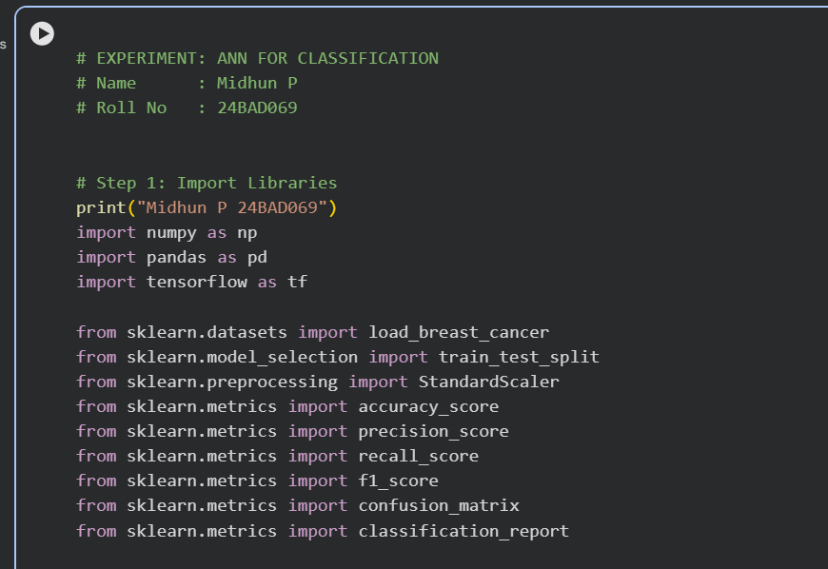
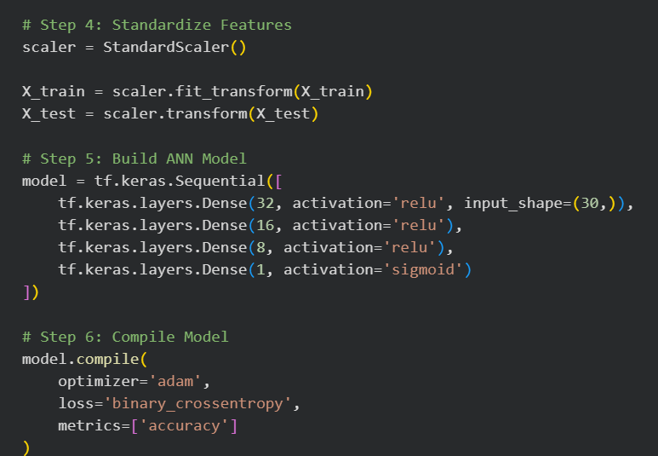

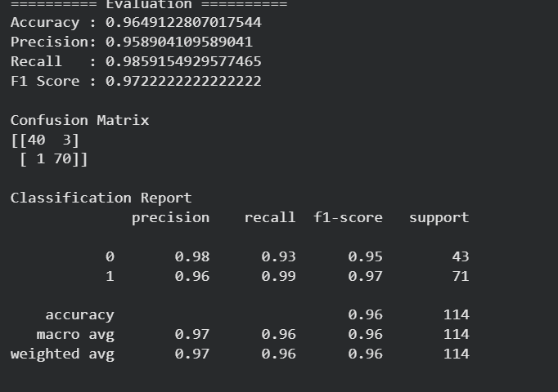

POST-LAB QUESTIONS (PROVIDE BRIEF ANSWERS TO THE FOLLOWING QUESTIONS)

- Why is the Adam optimizer commonly used in ANN training?

The Adam optimizer is widely used because it combines the advantages of Momentum and RMSProp optimization techniques. It automatically adjusts the learning rate for each parameter during training. This results in faster convergence and improved model performance. Adam works well for large datasets and deep neural networks. It is computationally efficient and requires minimal parameter tuning.

- Compare Mean Squared Error (MSE) and Mean Absolute Error (MAE). Which metric is more sensitive to outliers?

Mean Squared Error (MSE) calculates the average of squared prediction errors, while Mean Absolute Error (MAE) calculates the average of absolute errors. Squaring the errors causes MSE to penalize larger errors more heavily. Therefore, MSE is more sensitive to outliers than MAE. MAE provides a more robust measure when the dataset contains extreme values. Both metrics are commonly used to evaluate regression models.

- Why is the sigmoid activation function used in binary classification?

The sigmoid activation function converts input values into probabilities ranging between 0 and 1. This makes it suitable for binary classification tasks where the output has only two classes. The predicted probability can be compared with a threshold to determine the final class label. It is simple, differentiable, and works effectively with binary cross-entropy loss. Therefore, sigmoid is commonly used in the output layer of binary classifiers.

- How does increasing the number of hidden layers affect the performance of an ANN?

Increasing the number of hidden layers allows the ANN to learn more complex and abstract patterns from data. This can improve prediction accuracy for difficult problems. However, adding too many layers may increase training time and computational cost. It can also lead to overfitting if the model becomes too complex. Therefore, the number of hidden layers should be chosen carefully based on the dataset and application.

- Compare the evaluation metrics used for regression and classification tasks. Why are different metrics required for these problems?

Regression models are evaluated using metrics such as MSE, MAE, and RMSE because they measure prediction errors for continuous values. Classification models use Accuracy, Precision, Recall, F1-score, and Confusion Matrix to assess how correctly the classes are predicted. These metrics evaluate different aspects of classification performance, especially for imbalanced datasets. Since regression predicts numerical values and classification predicts categories, different evaluation methods are required. Choosing appropriate metrics ensures a more accurate assessment of model performance

ASSESSMENT
Description | Max Marks | Marks Awarded
Pre Lab Exercise | 5
In Lab Exercise | 10
Post Lab Exercise | 5
Viva | 10
Total | 30
Faculty Signature

